Exodus –
A People Moving Forward Together in Hope

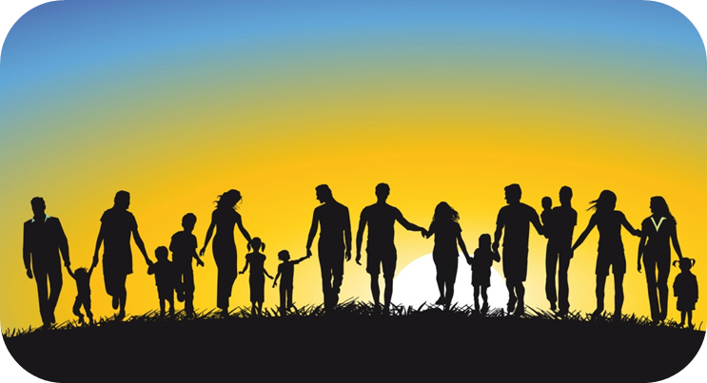
Forming God’s People
for the Future
Opening Responses
Reader We gather in the name of the Father:
All Who has a dream for humanity
and for all Creation
and entrusts this to mere men and women
to bring to fulfilment.

Reader We gather in the name of the Son:
All Who teaches his disciples through word and action
and commissioned them to pass on to others
all that they have learned from him.

Reader We gather in the name of the Holy Spirit:
All Who gives wisdom, knowledge and understanding to God’s people
so that in a world of change and uncertainty,
they can discern the will of God
and follow it.
Remembering the Journey
We will hear a couple of extracts from the Book of Exodus which tell us about how God prepared his people for their new life in the Promised Land. (Note: you may not use all of them!)
Thoughts for Reflection
- The Ten Commandments are familiar – but what would a society look like where people just do not do the things that God says they will not do because they are his people?
After the second extract:
- This actually follows a very long list of instructions about what the Ark of Covenant should be like – as well as how priests are to be ordained and vested. For our purposes, think about how we honour the God who dwells among us in our own day – and how we make him known to others.
After the third extract
- Moses glimpsed the Promised Land but did not live to see it. It reminds us that we are sowing seeds for a future that does not belong to us either. How do you feel about working hard in your own lifetime for things that you will not see but which future generations will build on?
After the fourth extract
- A time for honesty! How often do you think your parish priest – deacon – Sister – pastoral council and finance committee feel like Moses?
- Have you ever felt like it? (Not necessarily in a church setting but that is our focus today).
Exploring the Way
Our questions from Forward Together in Hope this time come from Education and Continuing Formation, Outreach and Young People.
Looking at our community’s data.
Information relevant to our reflective questions is presented to help our discussions.

Reflective Questions
- What good experiences have you had in the past and what opportunities would you like to see for ‘continuing formation ‘in the faith for members of our community?
- How can closer relationships be developed between the worshipping community, the school/schools the young people attend, and the families that belong to both?
- What good experiences has our community had regarding our call to be involved with other Christians, other faiths, all men and women of good will?
- How can our worshipping community become more immersed in the local community?
- What good experiences regarding Church life do the young people have in our community?
- How can the presence and witness of young people be more encouraged and supported in the community?

In Conclusion
- Given all the findings we have explored, is there anything we need to be doing to ensure a viable and flourishing community in 2020?
- Is there something we feel our community would like to add?
- Is there anything we do well that we would like to share with the wider diocese?

Closing Prayer Forward Together in Hope prayer

Glory be to the Father -
in whom we live and move
and have our being.

Glory be to the Son -
Whose name we bear
and who calls each of us
to be his disciples;
to build his Kingdom
and to go out into the world
and bear its fruit.

Glory be to the Holy Spirit -
pouring out grace and guidance,
forming us and renewing us.

Inspire us all
In the Diocese of Hexham and Newcastle
to live the Gospel,
to be open to change
and to move forward together



.

